AccessStructureCopier - Code Source

1-AccessStructureCopier - Ai Question - id 5
# Source: Person Source: Provided by: [Data Path: Persons Table -> ID Column: 1, Name_En Column: Motasem Essam] Written by: [Data Path: Persons Table -> ID Column: 1, Name_En Column: Motasem Essam] on [11/22/2025]
create Python program copy access file ,file name, tables, columns make , layout size and shape make me choose file and choose folder that i will save copy access file then delete data reset id to 1

2-AccessStructureCopier - Ai Answer - id 5
# Source: AI Source: Provided by: [Data Path: Persons Table -> ID Column: 1, Name_En Column: Motasem Essam] -> From: [ChatGPT] on [11/22/2025]
Got it! You want a Python program that:
- Lets you choose an Access database file (.accdb or .mdb).
- Lets you choose a folder to save a copy.
- Copies the Access file while keeping its structure (tables, columns).
- Deletes all data in the copy.
- Resets AutoNumber IDs to start from 1.
We can do this using tkinter for file/folder selection and pyodbc for Access DB operations. Here's a full Python script:
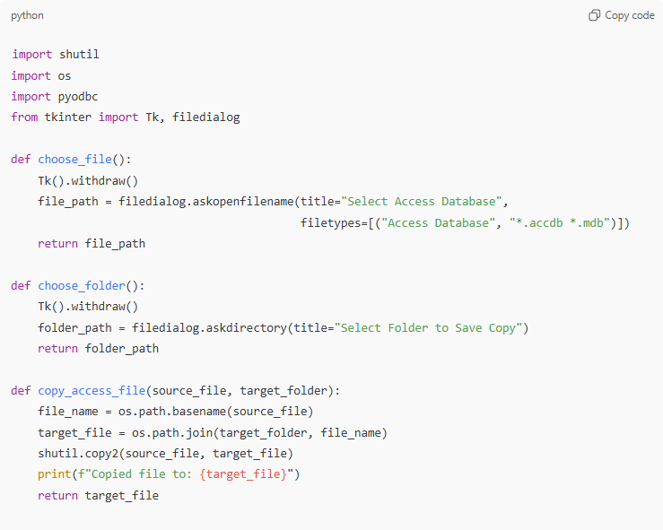
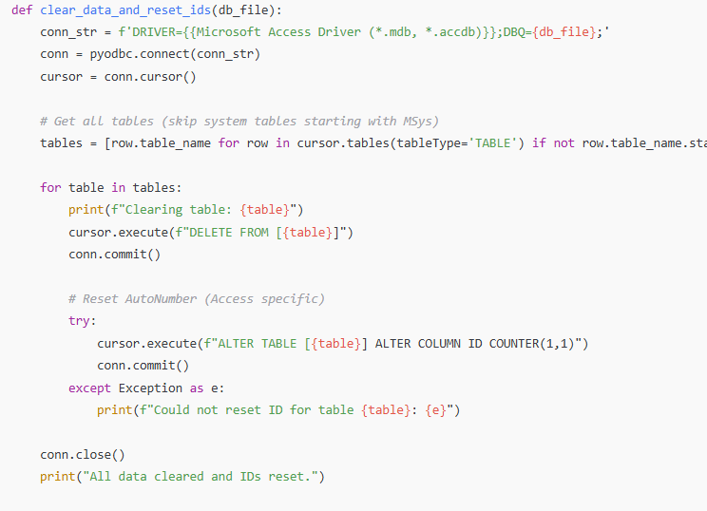
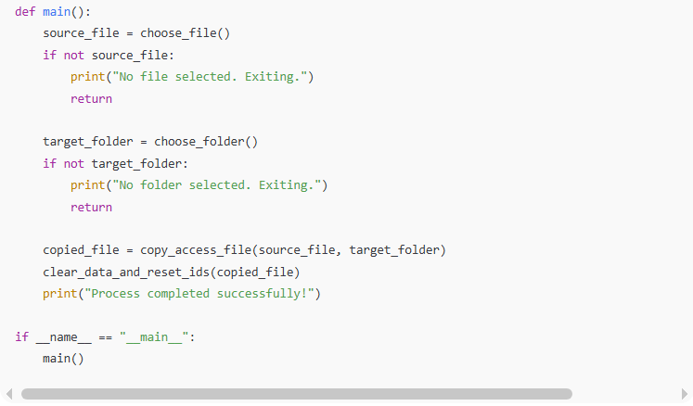
import shutil
import os
import pyodbc
from tkinter import Tk, filedialog

def choose_file():
Tk().withdraw()
file_path = filedialog.askopenfilename(title="Select Access Database",
filetypes=[("Access Database", "*.accdb *.mdb")])
return file_path

def choose_folder():
Tk().withdraw()
folder_path = filedialog.askdirectory(title="Select Folder to Save Copy")
return folder_path

def copy_access_file(source_file, target_folder):
file_name = os.path.basename(source_file)
target_file = os.path.join(target_folder, file_name)
shutil.copy2(source_file, target_file)
print(f"Copied file to: {target_file}")
return target_file

def clear_data_and_reset_ids(db_file):
conn_str = f'DRIVER={{Microsoft Access Driver (*.mdb, *.accdb)}};DBQ={db_file};'
conn = pyodbc.connect(conn_str)
cursor = conn.cursor()

# Get all tables (skip system tables starting with MSys)
tables = [row.table_name for row in cursor.tables(tableType='TABLE') if not row.table_name.startswith('MSys')]

for table in tables:
print(f"Clearing table: {table}")
cursor.execute(f"DELETE FROM [{table}]")
conn.commit()

# Reset AutoNumber (Access specific)
try:
cursor.execute(f"ALTER TABLE [{table}] ALTER COLUMN ID COUNTER(1,1)")
conn.commit()
except Exception as e:
print(f"Could not reset ID for table {table}: {e}")

conn.close()
print("All data cleared and IDs reset.")

def main():
source_file = choose_file()
if not source_file:
print("No file selected. Exiting.")
return

target_folder = choose_folder()
if not target_folder:
print("No folder selected. Exiting.")
return

copied_file = copy_access_file(source_file, target_folder)
clear_data_and_reset_ids(copied_file)
print("Process completed successfully!")

if __name__ == "__main__":
main()
✅ How it works:
- File selection with a file dialog.
- Folder selection for saving the copy.
- Copy the original Access file.
- Connect via pyodbc to delete data.
- Reset AutoNumber IDs (common ID column assumed).

A few notes:
- This assumes AutoNumber columns are named ID. If your tables have different AutoNumber column names, we need to detect them.
- Requires Microsoft Access Driver installed.
I can also make an improved version that detects AutoNumber columns automatically for each table so it works for any schema.
Do you want me to do that?

3-AccessStructureCopier - Ai Question - id 5
# Source: Person Source: Provided by: [Data Path: Persons Table -> ID Column: 1, Name_En Column: Motasem Essam] Written by: [Data Path: Persons Table -> ID Column: 1, Name_En Column: Motasem Essam] on [11/22/2025]
make this happen to all files inside folder I choose it

4-AccessStructureCopier - Ai Answer - id 5
# Source: AI Source: Provided by: [Data Path: Persons Table -> ID Column: 1, Name_En Column: Motasem Essam] -> From: [ChatGPT] on [11/22/2025]
Perfect! You want to process all Access files inside a selected folder, not just one file. We can modify the previous script so that it:
- Lets you choose a folder containing Access files.
- Lets you choose a destination folder for the copies.
- Iterates through all .accdb and .mdb files in the source folder.
- Copies each file.
- Clears all table data and resets AutoNumber IDs in the copied file.
Here’s a ready-to-use Python script:
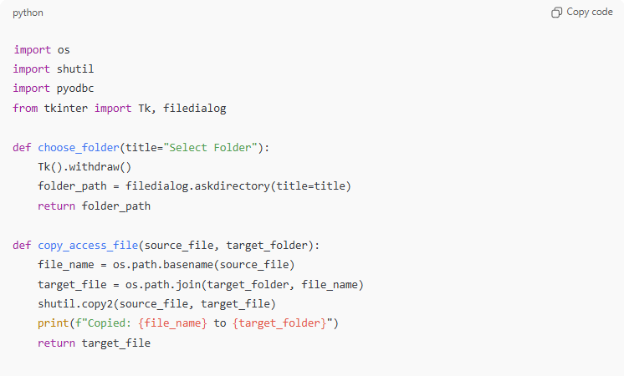
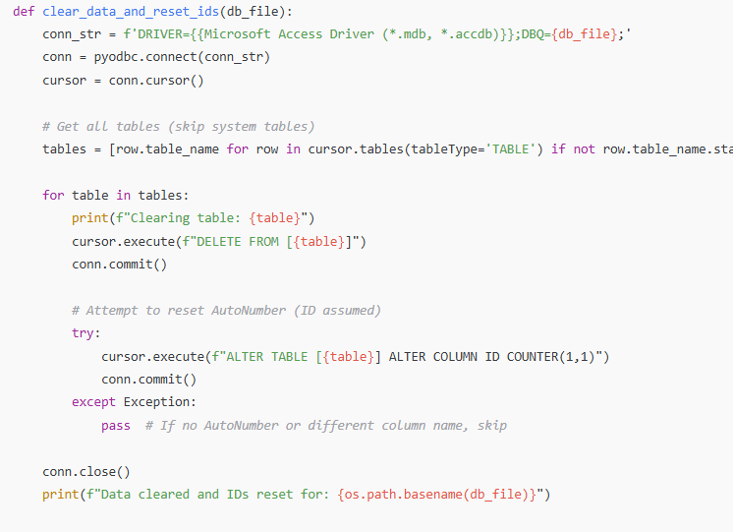
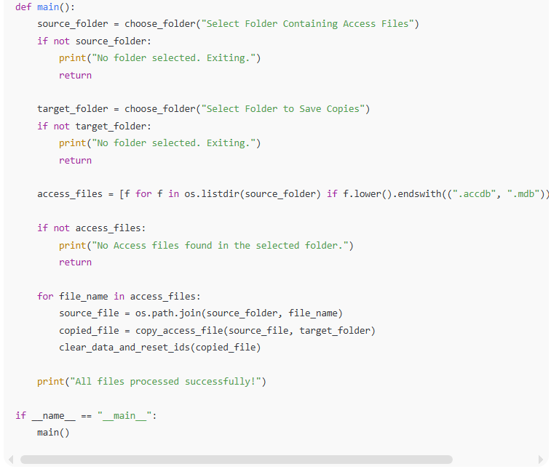
import os
import shutil
import pyodbc
from tkinter import Tk, filedialog

def choose_folder(title="Select Folder"):
Tk().withdraw()
folder_path = filedialog.askdirectory(title=title)
return folder_path

def copy_access_file(source_file, target_folder):
file_name = os.path.basename(source_file)
target_file = os.path.join(target_folder, file_name)
shutil.copy2(source_file, target_file)
print(f"Copied: {file_name} to {target_folder}")
return target_file

def clear_data_and_reset_ids(db_file):
conn_str = f'DRIVER={{Microsoft Access Driver (*.mdb, *.accdb)}};DBQ={db_file};'
conn = pyodbc.connect(conn_str)
cursor = conn.cursor()

# Get all tables (skip system tables)
tables = [row.table_name for row in cursor.tables(tableType='TABLE') if not row.table_name.startswith('MSys')]

for table in tables:
print(f"Clearing table: {table}")
cursor.execute(f"DELETE FROM [{table}]")
conn.commit()

# Attempt to reset AutoNumber (ID assumed)
try:
cursor.execute(f"ALTER TABLE [{table}] ALTER COLUMN ID COUNTER(1,1)")
conn.commit()
except Exception:
pass # If no AutoNumber or different column name, skip

conn.close()
print(f"Data cleared and IDs reset for: {os.path.basename(db_file)}")

def main():
source_folder = choose_folder("Select Folder Containing Access Files")
if not source_folder:
print("No folder selected. Exiting.")
return

target_folder = choose_folder("Select Folder to Save Copies")
if not target_folder:
print("No folder selected. Exiting.")
return

access_files = [f for f in os.listdir(source_folder) if f.lower().endswith((".accdb", ".mdb"))]

if not access_files:
print("No Access files found in the selected folder.")
return

for file_name in access_files:
source_file = os.path.join(source_folder, file_name)
copied_file = copy_access_file(source_file, target_folder)
clear_data_and_reset_ids(copied_file)

print("All files processed successfully!")

if __name__ == "__main__":
main()

✅ What this script does:
- Select source folder with Access files.
- Select destination folder for copies.
- Copies each .accdb or .mdb file.
- Deletes all data in all tables (skipping system tables).
- Attempts to reset AutoNumber IDs (column assumed ID).

⚠️ Note: If AutoNumber columns have names other than ID, the script won’t reset them correctly. I can create a version that detects AutoNumber columns automatically for each table so it works for any schema.
Do you want me to do that?

5-AccessStructureCopier - Ai Question - id 5
# Source: Person Source: Provided by: [Data Path: Persons Table -> ID: 1, Name_En: Motasem Essam, Email Address: motasem.essam.prototypedoteg.com@gmail.com] Written by: [Data Path: Persons Table -> ID Column: 1, Name_En Column: Motasem Essam] on [11/22/2025]
make them version that handles subfolders recursively

6-AccessStructureCopier - Ai Answer - id 5
# Source: AI Source: Provided by: [Data Path: Persons Table -> ID Column: 1, Name_En Column: Motasem Essam] -> From: [ChatGPT] on [11/22/2025]
Got it! You want a recursive version that:
- Processes all .accdb and .mdb files inside a folder and all its subfolders.
- Copies them to a destination folder, keeping the subfolder structure.
- Deletes all data and resets AutoNumber IDs in the copies.
Here’s a complete Python script:
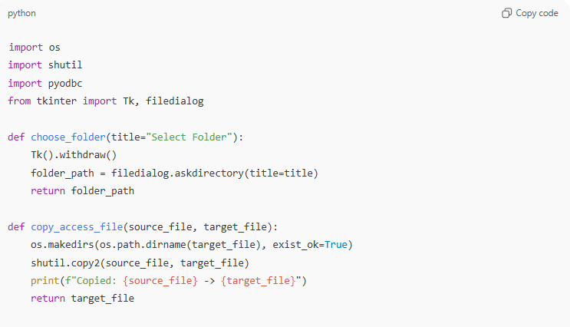
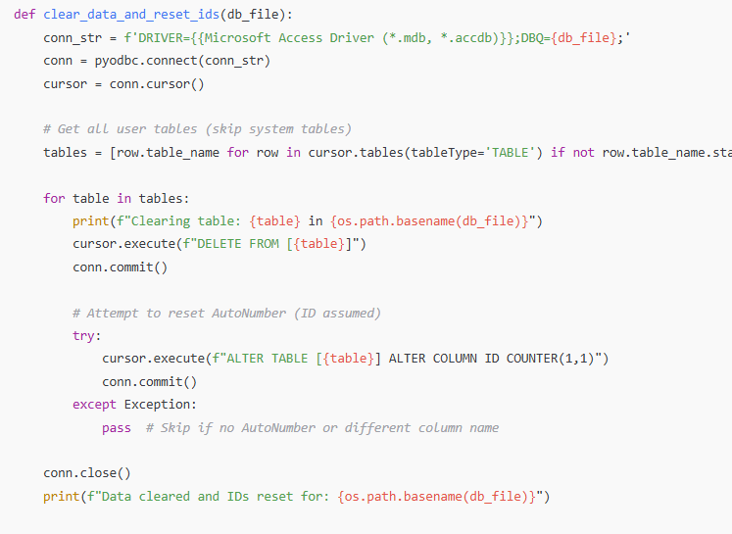
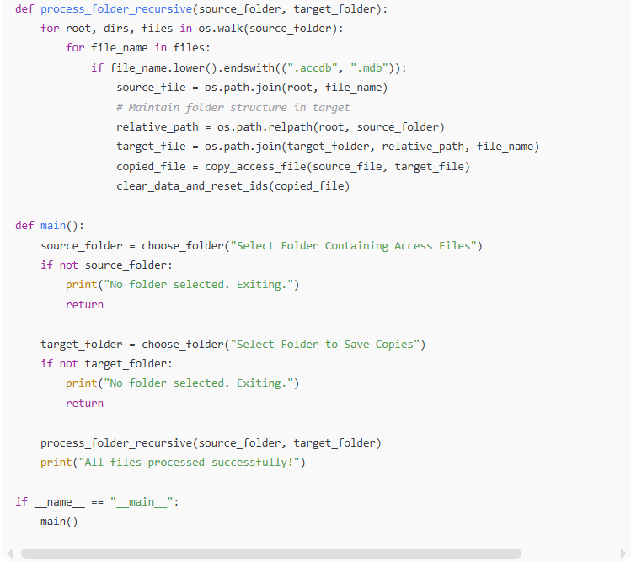
import os
import shutil
import pyodbc
from tkinter import Tk, filedialog

def choose_folder(title="Select Folder"):
Tk().withdraw()
folder_path = filedialog.askdirectory(title=title)
return folder_path

def copy_access_file(source_file, target_file):
os.makedirs(os.path.dirname(target_file), exist_ok=True)
shutil.copy2(source_file, target_file)
print(f"Copied: {source_file} -> {target_file}")
return target_file

def clear_data_and_reset_ids(db_file):
conn_str = f'DRIVER={{Microsoft Access Driver (*.mdb, *.accdb)}};DBQ={db_file};'
conn = pyodbc.connect(conn_str)
cursor = conn.cursor()

# Get all user tables (skip system tables)
tables = [row.table_name for row in cursor.tables(tableType='TABLE') if not row.table_name.startswith('MSys')]

for table in tables:
print(f"Clearing table: {table} in {os.path.basename(db_file)}")
cursor.execute(f"DELETE FROM [{table}]")
conn.commit()

# Attempt to reset AutoNumber (ID assumed)
try:
cursor.execute(f"ALTER TABLE [{table}] ALTER COLUMN ID COUNTER(1,1)")
conn.commit()
except Exception:
pass # Skip if no AutoNumber or different column name

conn.close()
print(f"Data cleared and IDs reset for: {os.path.basename(db_file)}")

def process_folder_recursive(source_folder, target_folder):
for root, dirs, files in os.walk(source_folder):
for file_name in files:
if file_name.lower().endswith((".accdb", ".mdb")):
source_file = os.path.join(root, file_name)
# Maintain folder structure in target
relative_path = os.path.relpath(root, source_folder)
target_file = os.path.join(target_folder, relative_path, file_name)
copied_file = copy_access_file(source_file, target_file)
clear_data_and_reset_ids(copied_file)

def main():
source_folder = choose_folder("Select Folder Containing Access Files")
if not source_folder:
print("No folder selected. Exiting.")
return

target_folder = choose_folder("Select Folder to Save Copies")
if not target_folder:
print("No folder selected. Exiting.")
return

process_folder_recursive(source_folder, target_folder)
print("All files processed successfully!")

if __name__ == "__main__":
main()

✅ Features of this version:
- Processes all files recursively, including subfolders.
- Maintains the subfolder structure in the destination folder.
- Deletes all table data and resets AutoNumber IDs.
- Skips system tables.

⚠️ Note: AutoNumber reset still assumes column name ID. For a fully robust version that detects AutoNumber columns automatically, it’s slightly more advanced but possible.
Do you want me to implement automatic AutoNumber detection for every table?

7-AccessStructureCopier - Ai Question - id 5
# Source: Person Source: Provided by: [Data Path: Persons Table -> ID: 1, Name_En: Motasem Essam, Email Address: motasem.essam.prototypedoteg.com@gmail.com] Written by: [Data Path: Persons Table -> ID Column: 1, Name_En Column: Motasem Essam] on [11/22/2025]
if file need password give me window to write it

8-AccessStructureCopier - Ai Answer - id 5
# Source: AI Source: Provided by: [Data Path: Persons Table -> ID Column: 1, Name_En Column: Motasem Essam] -> From: [ChatGPT] on [11/22/2025]
Below is a modified version of your script that detects when an Access file requires a password and opens a Tkinter password window so the user can enter it.
The key changes:
- Wrap the pyodbc connection in a try/except
- If connection fails due to password protection, show a password dialog using tkinter.simpledialog.askstring
- Retry the connection using the password

✅ Updated Code With Password Prompt
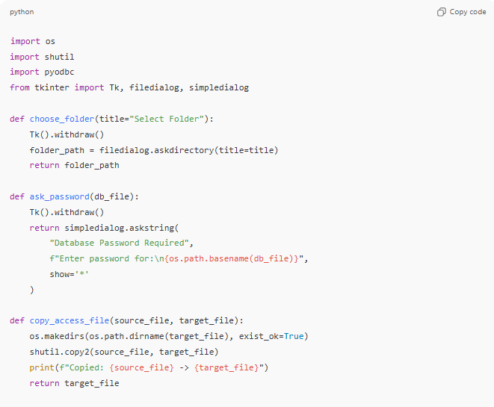
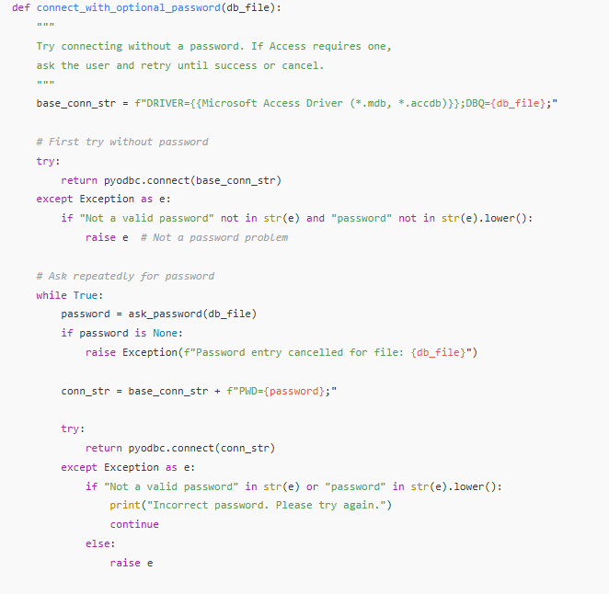
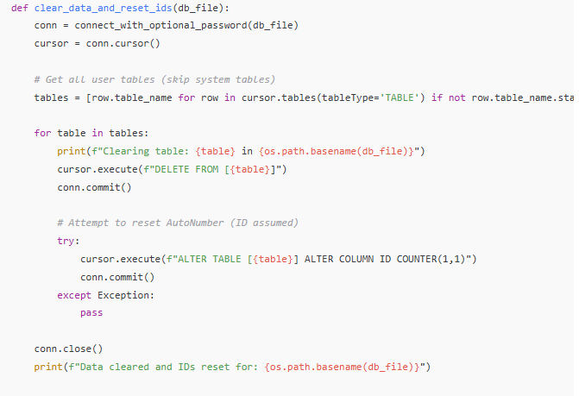
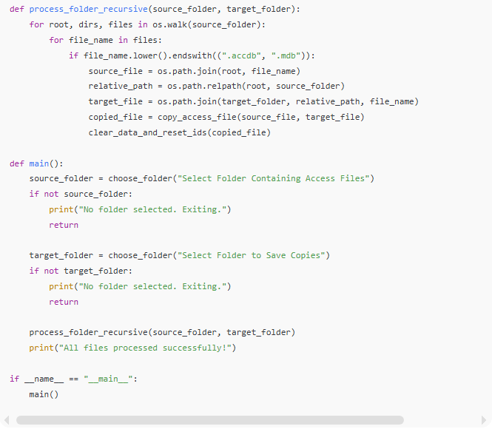
import os
import shutil
import pyodbc
from tkinter import Tk, filedialog, simpledialog

def choose_folder(title="Select Folder"):
Tk().withdraw()
folder_path = filedialog.askdirectory(title=title)
return folder_path

def ask_password(db_file):
Tk().withdraw()
return simpledialog.askstring(
"Database Password Required",
f"Enter password for:\n{os.path.basename(db_file)}",
show='*'
)

def copy_access_file(source_file, target_file):
os.makedirs(os.path.dirname(target_file), exist_ok=True)
shutil.copy2(source_file, target_file)
print(f"Copied: {source_file} -> {target_file}")
return target_file

def connect_with_optional_password(db_file):
"""
Try connecting without a password. If Access requires one,
ask the user and retry until success or cancel.
"""
base_conn_str = f"DRIVER={{Microsoft Access Driver (*.mdb, *.accdb)}};DBQ={db_file};"

# First try without password
try:
return pyodbc.connect(base_conn_str)
except Exception as e:
if "Not a valid password" not in str(e) and "password" not in str(e).lower():
raise e # Not a password problem

# Ask repeatedly for password
while True:
password = ask_password(db_file)
if password is None:
raise Exception(f"Password entry cancelled for file: {db_file}")

conn_str = base_conn_str + f"PWD={password};"

try:
return pyodbc.connect(conn_str)
except Exception as e:
if "Not a valid password" in str(e) or "password" in str(e).lower():
print("Incorrect password. Please try again.")
continue
else:
raise e

def clear_data_and_reset_ids(db_file):
conn = connect_with_optional_password(db_file)
cursor = conn.cursor()

# Get all user tables (skip system tables)
tables = [row.table_name for row in cursor.tables(tableType='TABLE') if not row.table_name.startswith('MSys')]

for table in tables:
print(f"Clearing table: {table} in {os.path.basename(db_file)}")
cursor.execute(f"DELETE FROM [{table}]")
conn.commit()

# Attempt to reset AutoNumber (ID assumed)
try:
cursor.execute(f"ALTER TABLE [{table}] ALTER COLUMN ID COUNTER(1,1)")
conn.commit()
except Exception:
pass

conn.close()
print(f"Data cleared and IDs reset for: {os.path.basename(db_file)}")

def process_folder_recursive(source_folder, target_folder):
for root, dirs, files in os.walk(source_folder):
for file_name in files:
if file_name.lower().endswith((".accdb", ".mdb")):
source_file = os.path.join(root, file_name)
relative_path = os.path.relpath(root, source_folder)
target_file = os.path.join(target_folder, relative_path, file_name)
copied_file = copy_access_file(source_file, target_file)
clear_data_and_reset_ids(copied_file)

def main():
source_folder = choose_folder("Select Folder Containing Access Files")
if not source_folder:
print("No folder selected. Exiting.")
return

target_folder = choose_folder("Select Folder to Save Copies")
if not target_folder:
print("No folder selected. Exiting.")
return

process_folder_recursive(source_folder, target_folder)
print("All files processed successfully!")

if __name__ == "__main__":
main()

✅ What This Adds
✔ Detects when Access database requires a password
✔ Shows a GUI password prompt (masked)
✔ Retries until correct password is given or user cancels
✔ Works for both .accdb and .mdb

If you want, I can also:
🔹 Add caching so you only enter each password once
🔹 Allow saving passwords securely
🔹 Add progress bars or a nicer GUI
Just tell me!

